BLOCKCHAIN TECHNOLOGIES MINI-PROJECT
on
AI Prompt MarketPlace – Blockchain-Based Platform
for Buying and Selling AI Prompts

Submitted By
Rahul Aitla (01)
Chetan Banjan (05)
Maitreya Dongardive (20)

Under the Guidance of

Dr. Gauri Deshpande

Department of Computer Science & Engineering (Data Science)

Academic Year :- 2026-27
INDEX
SR. NO. | CHAPTER NAME | PAGE NO.
1 | Introduction | 1
2 | Problem Statement | 1
3 | Objectives | 1
4 | Technologies Used | 2
5 | System Architecture | 2
6 | Methodology | 2-3
7 | Smart Contract | 4
8 | Testing | 4
9 | Result | 5-8
10 | Advantages | 8
11 | Limitations | 8
12 | Future Scope | 8
13 | Conclusion | 9
14 | References | 9

1. Introduction
Blockchain is a distributed ledger technology that records transactions in a sequence of blocks. Once transactions are confirmed, they become difficult to alter, providing transparency and security. Smart contracts are programs deployed on a blockchain that automatically execute predefined operations when specified conditions are met.
In this project, AI Prompt MarketPlace is a blockchain-based marketplace where sellers publish AI prompt listings and buyers purchase them using ETH. A Solidity smart contract records each listing on-chain and handles exact-price payments, transferring funds directly to the seller's wallet. The platform supports wallet-based sign-in using MetaMask, a live playground where buyers can try prompts before purchasing, purchase-gated file downloads through signed links, and buyer reviews. This improves trust, transparency and payment security between prompt sellers and buyers.

2. Problem Statement
Traditional platforms for selling AI prompts depend on centralized payment processors, give buyers no reliable way to check prompt quality before paying, and provide little transparency into transactions. A blockchain-based marketplace can secure payments through a smart contract, record listings and purchases on-chain, and let buyers verify purchases directly against the blockchain.

3. Objectives
- To understand the basic concept of blockchain.
- To develop a smart contract for marketplace listings and payments.
- To record prompt listings and purchases on the blockchain.
- To connect a web application to the contract through a crypto wallet.
- To demonstrate a practical application of smart contracts.

4. Technologies Used
Technology | Purpose
Solidity | Smart contract development
Hardhat | Smart contract testing and deployment
Ethereum (Hardhat / Sepolia) | Blockchain platform
MetaMask | Wallet connection and transactions
Next.js, React, TypeScript | Frontend and backend framework
PostgreSQL + Prisma | Database and ORM
wagmi, viem, RainbowKit | Wallet connection and contract interaction
SIWE + JWT | Wallet-based authentication
Groq API | Live prompt playground LLM

5. System Architecture
Buyer / Seller
|
↓
User Interface
(Next.js, React, TypeScript)
|
↓
Backend API + Database
(Next.js API routes, Postgres)
|
↓
Smart Contract (
|
↓
Ethereum Blockchain (Hardhat / EVM)
|
↓
On-chain Payments and Purchase Records
Fig 5.1: AI Prompt MarketPlace System Architecture

6. Methodology

Step 1
Design a Solidity smart contract for listing and purchasing AI prompt assets.

Step 2
Define marketplace data such as:
- Asset ID and seller wallet address
- Listing price in wei
- Purchase status per buyer

Step 3
Implement listAsset() and purchase() functions with exact-payment verification and event emission.

Step 4
Deploy the smart contract on a local Ethereum blockchain using Hardhat.

Step 5
Connect the Next.js frontend to the contract using wagmi, viem, RainbowKit and MetaMask.

Step 6
Allow sellers to publish prompt listings on-chain and buyers to purchase them with ETH; gate prompt file downloads with signed links.

Step 7
Run the Hardhat test suite to verify listing validation, exact-payment purchase, and duplicate-purchase protection.

Implementation and Results

7. Smart Contract
A simple contract can contain:
// SPDX-License-Identifier: MIT
pragma solidity ^0.8.24;

import "@openzeppelin/contracts/utils/ReentrancyGuard.sol";

contract Marketplace is ReentrancyGuard {
mapping(uint256 => address payable) public assetSeller;
mapping(uint256 => uint256) public assetPrice;
mapping(uint256 => mapping(address => bool)) public hasPurchased;

event AssetListed(uint256 indexed assetId, address indexed seller, uint256 price);
event Purchased(uint256 indexed assetId, address indexed buyer, address indexed seller, uint256 amount, uint256 timestamp);

function listAsset(uint256 assetId, uint256 priceWei) external {
require(assetId != 0, "assetId 0 is reserved");
require(assetSeller[assetId] == address(0), "Already listed");
require(priceWei > 0, "Price must be > 0");
assetSeller[assetId] = payable(msg.sender);
assetPrice[assetId] = priceWei;
emit AssetListed(assetId, msg.sender, priceWei);
}

function purchase(uint256 assetId) external payable nonReentrant {
address payable seller = assetSeller[assetId];
require(seller != address(0), "Not listed");
require(msg.value == assetPrice[assetId], "Incorrect payment amount");
require(!hasPurchased[assetId][msg.sender], "Already purchased");

hasPurchased[assetId][msg.sender] = true;

(bool sent, ) = seller.call{value: msg.value}("");
require(sent, "Transfer to seller failed");

emit Purchased(assetId, msg.sender, seller, msg.value, block.timestamp);
}
}

8. Testing
Test Case | Input | Expected Result | Status
TC01 | List asset with valid id and price | AssetListed event emitted | Pass
TC02 | List asset with assetId = 0 | Transaction reverts | Pass
TC03 | List the same assetId twice | Transaction reverts | Pass
TC04 | List asset with price 0 | Transaction reverts | Pass
TC05 | Purchase below listed price | Transaction reverts | Pass
TC06 | Purchase above listed price | Transaction reverts | Pass
TC07 | Purchase with exact price | ETH sent to seller, Purchased event emitted | Pass
TC08 | Same buyer purchases twice | Transaction reverts | Pass
TC09 | Purchase unlisted assetId | Transaction reverts | Pass

9. Result
The AI Prompt MarketPlace platform was successfully implemented and tested on a local Ethereum blockchain using Hardhat. Sellers can publish prompt listings on-chain, and buyers can connect a wallet with MetaMask, try prompts in a live playground, purchase listings with exact ETH payments, and download the prompt file through a signed link. All nine smart contract test cases passed.

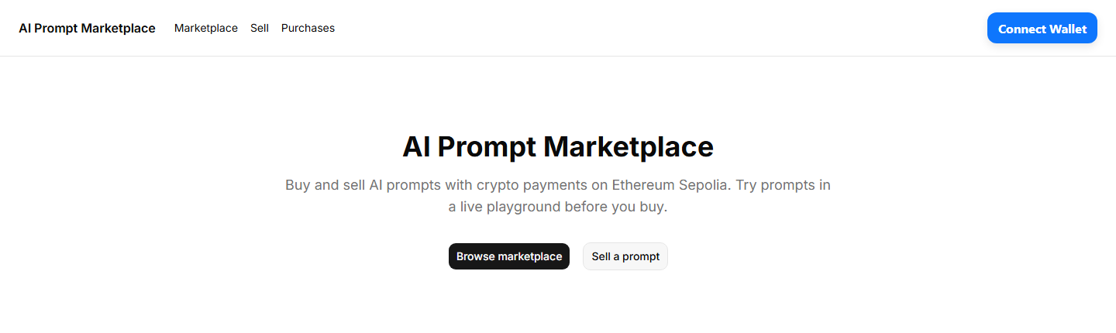
Fig 9.1: AI Prompt MarketPlace Landing Page
The landing page introduces the AI Prompt MarketPlace and highlights its main purpose: buying and selling AI prompts with ETH payments secured by a smart contract.

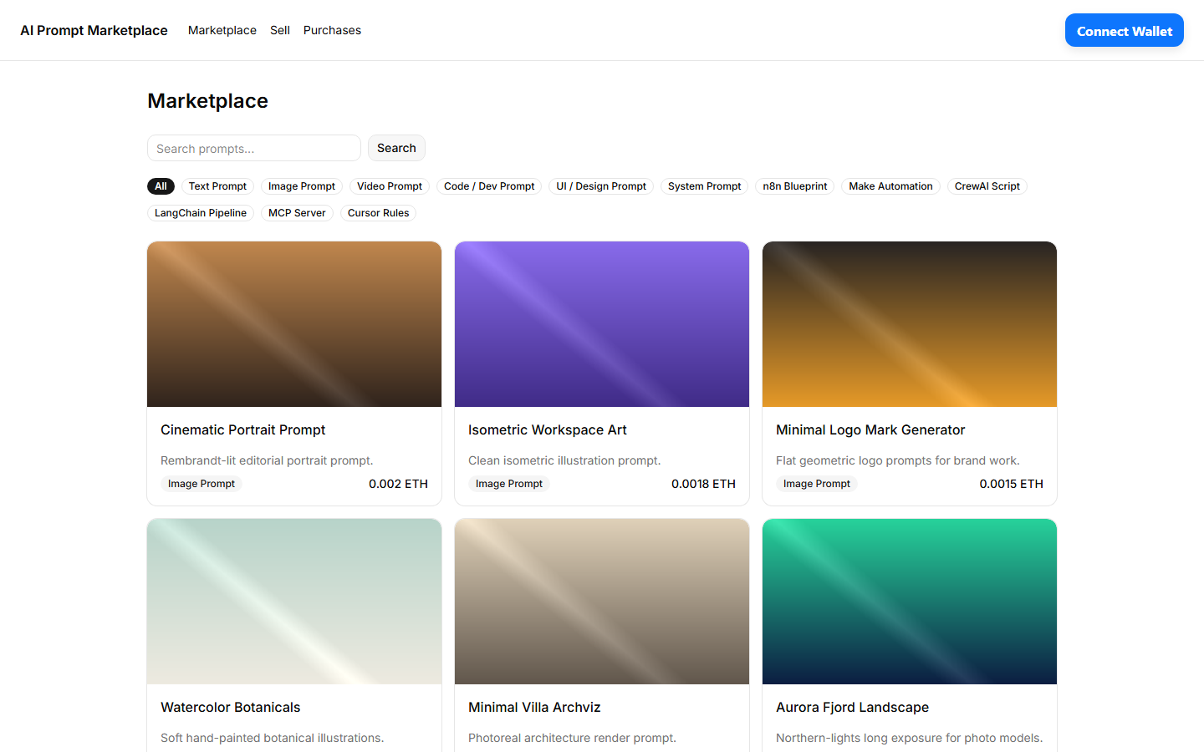
Fig 9.2: Marketplace Catalog with Prompt Listings
The catalog displays published prompt listings with category filters, text search, and prices denominated in ETH.

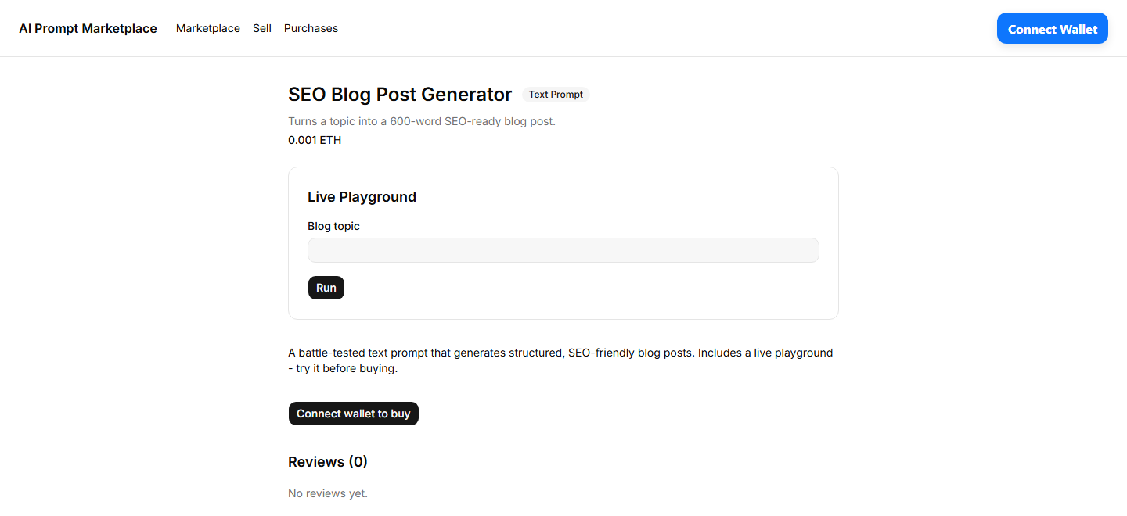
Fig 9.3: Asset Detail Page with Live Playground
Buyers can view the prompt details and try the prompt in a live LLM playground before deciding to purchase it.

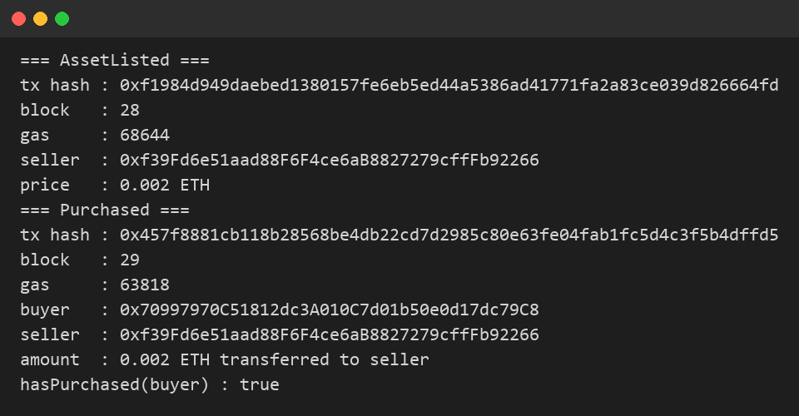
Fig 9.4: On-chain Listing and Purchase Transactions
The AssetListed and Purchased events record the listing and the payment on the blockchain, along with transaction hashes, block numbers and gas used.

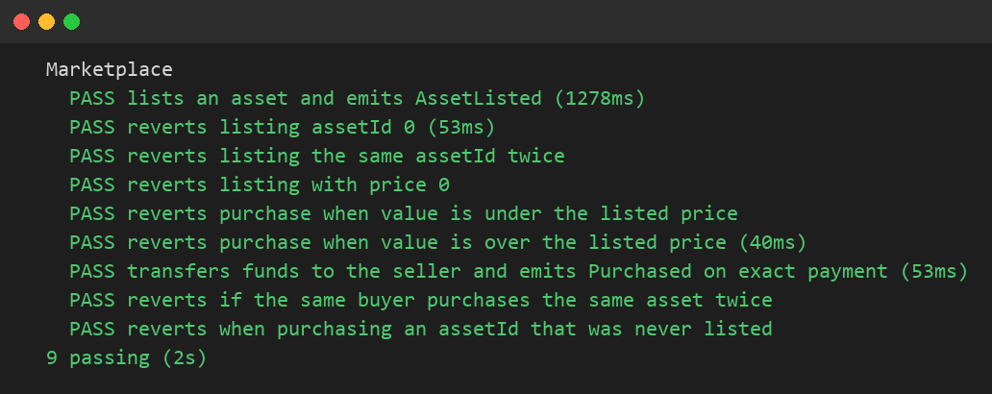
Fig 9.5: Smart Contract Test Results (Hardhat)
All nine test cases pass, covering listing validation, exact-payment purchase, and duplicate-purchase protection.

10. Advantages
- Secures payments using a smart contract with exact-price enforcement.
- Improves transparency – listings and purchases are recorded on-chain.
- Payments go directly to the seller with no intermediary.
- Buyers can try prompts in a live playground before paying.
- Demonstrates practical use of blockchain technology.

11. Limitations
- Requires a crypto wallet (MetaMask) and blockchain access.
- Blockchain transactions are difficult to reverse once confirmed.
- Transaction (gas) fees apply on public blockchains.
- The project is a prototype running on a local/test network, not a full production marketplace.

12. Future Scope
The system can be extended by adding:
- Deploy the contract on a public testnet or mainnet
- Buyer ratings and on-chain reviews
- Dispute resolution and refund mechanism
- IPFS or decentralized storage for prompt files
- NFT-based licenses for prompt ownership
- Support for more prompt categories and collections
- Mobile-friendly interface and purchase notifications

13. Conclusion
The project demonstrates the use of blockchain and smart contracts for a decentralized AI prompt marketplace. Listings and purchases are managed by a smart contract, payments are transferred directly to sellers in ETH, and prompt downloads are gated by verified on-chain purchases. Testing on a local blockchain successfully demonstrated the listing, purchase and payment flow.

14. References
- https://ethereum.org/developers/docs/
- https://docs.soliditylang.org/
- https://hardhat.org/docs
- https://nextjs.org/docs
- https://docs.openzeppelin.com/contracts

